
Babu Madhav Institute of Information Technology
Uka Tarsadia University
Academic Year: 2026–2027

Virtual Classroom Management System
Subject: Cloud Computing

Submitted By:
Jailly Maniya – 202504102510001(Msc IT)
Hetvi Vamja -202206100110059
Shruti Hansaliya -202206100110060

Guided By:
Dr.Bhumika Patel

INDEX

No | Title | Page No
1 | Introduction | 03
2 | Cloud Services Used | 04
3 | Cloud Services Integration | 05
3 | Architecture Design | 07
4 | Component Explanation | 08
5 | System Work Flow | 09
6 | Conclusion | 11

- Introduction

The Virtual Classroom Management System is a web-based platform designed to make online learning simple, organized, and interactive for both students and faculty. It is developed using ASP.NET Core MVC and deployed on cloud services to ensure scalability, security, and reliability.
The system allows users to register and log in using email/password or Google Sign-In, along with features like password recovery and profile management. Faculty can create and manage classrooms, invite students via email, and upload assignments and study materials. Students can join classrooms, access resources, and submit assignments easily.
All application data is stored in Azure SQL Database, while files such as assignments and materials are stored in Azure Blob Storage. The system also uses role-based access control to provide secure access based on user roles.
Overall, the system provides a centralized and efficient platform that improves communication, simplifies classroom management, and enhances the online learning experience.

Cloud Services Used

Cloud Service | Type | Purpose
Microsoft Azure App Service | PaaS | Hosts the ASP.NET Core web application and handles user requests over the internet
Microsoft Azure SQL Database | PaaS | Stores structured data such as user details, classrooms, assignments, and submissions
Microsoft Azure Blob Storage | IaaS/PaaS | Stores files like assignment uploads, notes, and other documents securely

External APIs (Cloud / Third-Party Services)

External API | Provider | Purpose | Integrated With
Google Identity API (Google Sign-In) | Google | User authentication & registration using Google accounts | ASP.NET Core Authentication
SendGrid API | Twilio | Sending emails (OTP, invitations, notifications) | Notification System

- Cloud service Integration
- Microsoft Azure App Service (Hosting)
Steps:
- Right-click project → Publish
- Select Azure → App Service
- Click Create New Instance
- Choose:
App Name
Region
Pricing Plan (Free / Basic / Standard)
- Click Publish
When You Change Code
- After making changes → click Publish again
- Visual Studio rebuilds and redeploys
- Azure automatically updates the running app
How it works:
- Your ASP.NET Core MVC app is hosted on cloud
- Users access it via URL
- Azure automatically handles scaling and uptime

- Microsoft Azure SQL Database (Data Storage)
Steps:
- Create Azure SQL Database
- Configure server, username, password
- Allow firewall access
- Copy connection string
- Add it in appsettings.json
- Use Entity Framework Core to connect(Apply migration and update database)
How it works:
- Stores structured data (users, classrooms, assignments)
- Backend interacts using EF Core
- Data is securely stored and accessible anytime

- Microsoft Azure Blob Storage (File Storage)
Steps:
- Create Storage Account
- Create Blob Container
- Get connection string
- Install NuGet package: Azure.Storage.Blobs
- Create Blob Service class
- Upload/download files using code
How it works:
- Stores files like PDFs, assignments
- Generates URL to access files
- Keeps database lightweight (only file links stored)

- Google Identity API (Google Sign-In)
Steps:
- Go to Google Cloud Console
- Create OAuth credentials
- Add redirect URI
- Get Client ID & Secret
- Configure in ASP.NET Core Authentication
How it works:
- User logs in using Google account
- Google verifies identity
- Your app receives user info and logs them in

- Twilio SendGrid API (Email Service)
Steps:
- Create SendGrid account
- Generate API key
- Add API key in appsettings
- Install MailKit / SendGrid package
- Create Email Service class
- Send emails (OTP, invitations)
How it works:
- Sends emails from your app
- Used for:
  - Password reset
  - Classroom invitations
  - Notifications

Architecture Design

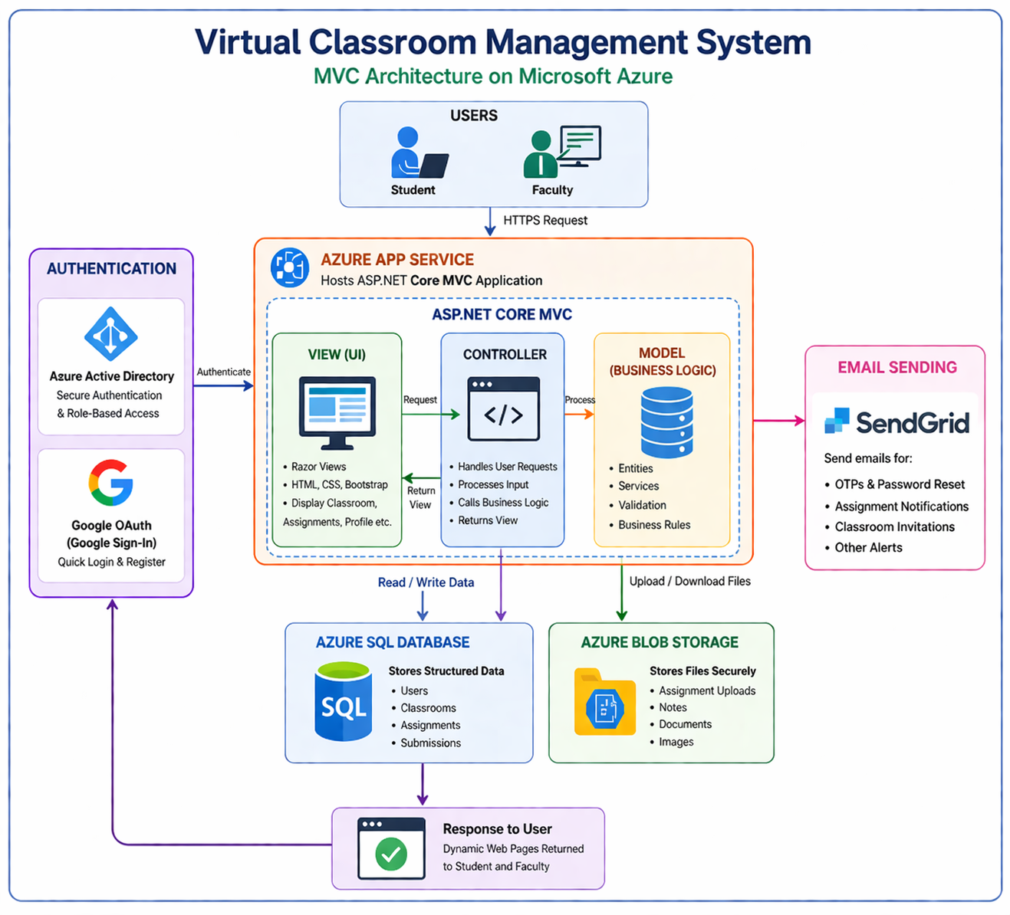

5. Component Explanation
The Virtual Classroom System is built using a modern web architecture that ensures scalability, security, and smooth user experience. The system is divided into multiple layers including frontend, authentication, backend logic, data storage, and monitoring. Each component works together to provide seamless classroom management, assignment handling, and live interaction between faculty and students.

1. Frontend Layer
The frontend layer provides the user interface for students and faculty to interact with the system. It is developed using ASP.NET Core MVC, which renders dynamic web pages for features like classroom management, assignments, and live sessions. The UI is designed to be responsive and user-friendly for smooth navigation.

2. Authentication Layer
The authentication layer ensures secure access to the system. It uses Google Sign-In (Google Identity API) along with ASP.NET Core Authentication to verify user identity. It also supports password-based login, password recovery using email (OTP/reset link), and role-based access control for students and faculty.

3. Application / Backend Logic Layer
The backend is built using ASP.NET Core, where all business logic is implemented. It handles operations such as classroom creation, student enrollment, assignment management, file uploads, and live session scheduling. The system processes user requests and ensures proper data flow between frontend and database.

4. API & Integration Layer
External services are integrated into the system to enhance functionality. Azure Blob Storage is used for file storage, SendGrid API is used for sending emails (OTP, invitations), and Azure Communication Services enables live session capabilities. These APIs allow the system to extend beyond basic functionality.

5. Data Layer
The data layer uses Microsoft Azure SQL Database (cloud-based database) to store structured data such as user details, classrooms, assignments, and submissions. Unlike a local SQL Server, this cloud database ensures high availability, scalability, and secure remote access. For file storage, Azure Blob Storage is used to securely store assignment files and submissions.

6. System Workflow

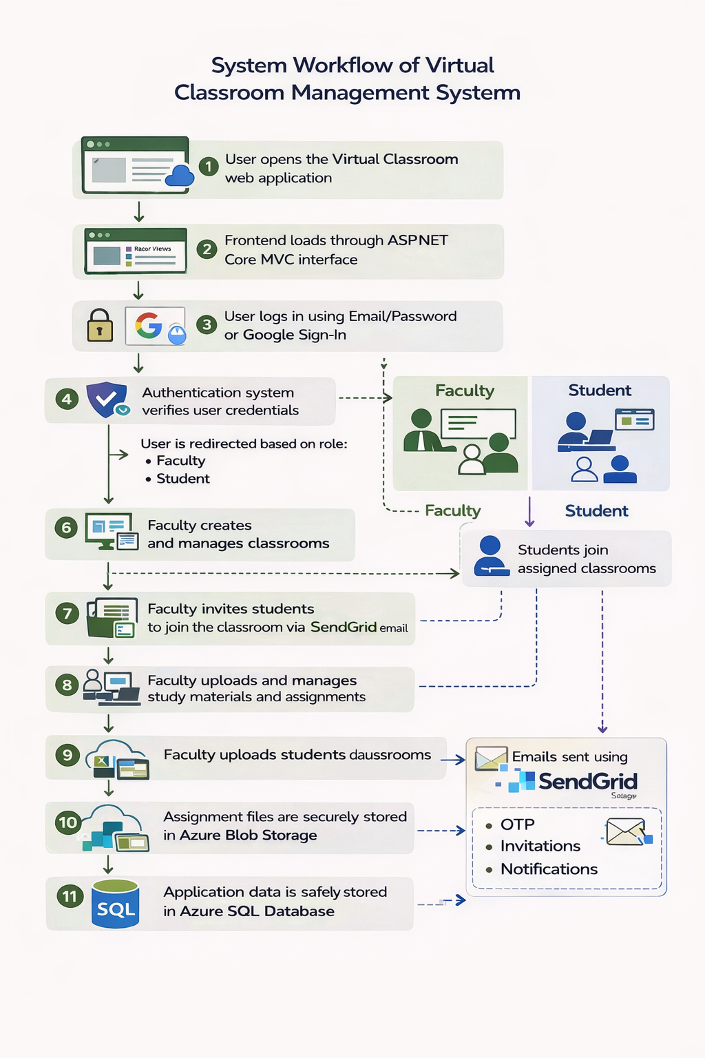

- User opens the Virtual Classroom web application
- Frontend loads through ASP.NET Core MVC interface
- User logs in using Email/Password or Google Sign-In
- Authentication system verifies user credentials
- User is redirected based on role (Faculty / Student)
- Faculty creates classrooms and manages class details
- Faculty invites students to join the classroom via email using SendGrid
- Faculty can view the list of students who joined the classroom
- Faculty uploads study materials and assignments for the classroom
- Students join classrooms
- Students view and download study materials uploaded by faculty
- Students submit assignments before the deadline
- Assignment files and materials are stored in Azure Blob Storage
- Application data is stored in Azure SQL Database
- Emails (OTP, invitations, notifications) are sent using SendGrid

7. Conclusion

The Virtual Classroom System successfully provides a simple and efficient platform for managing online learning activities. It enables faculty to create and manage classrooms, share study materials, and assign work, while allowing students to easily access content, submit assignments, and stay connected with their classes. The integration of features like Google Sign-In, email notifications using SendGrid, and cloud storage through Azure ensures a secure, scalable, and user-friendly experience.
Overall, the project demonstrates how cloud-based solutions can improve communication, streamline academic processes, and enhance the overall learning experience for both students and faculty.

